FML U3 REMAINING TOPICS

✅ Subset Selection Techniques in Machine Learning
⭐ Meaning
Subset selection refers to a group of techniques used to identify and retain only the most important features from a dataset while removing irrelevant or less useful ones.
The main purpose of subset selection is to make the model simpler, faster, and less prone to overfitting, while still maintaining good predictive accuracy.

✅ Why Subset Selection is Important
- It reduces the complexity of the model by removing unnecessary features.
- It improves the interpretability of the model, since fewer features are used.
- It helps avoid overfitting by eliminating noisy or redundant variables.
- It decreases training time, especially when the dataset has many features.

🎯 Techniques Under Subset Selection
1️⃣ Best Subset Selection
Best subset selection tries every possible combination of features and chooses the combination that gives the best model performance, usually based on metrics like R², adjusted R², or error.
For example, if there are 4 features, it checks models with 1 feature, 2 features, 3 features, and all 4 features to find the best set.
Although it gives the best subset, it becomes extremely slow when the number of features increases.

2️⃣ Forward Selection
Forward selection starts with zero features in the model.
At each step, it adds the feature that improves the model the most.
The process continues until adding more features does not significantly improve performance.
It is faster than best subset selection and works well when we expect only a few features to be useful.

3️⃣ Backward Elimination
Backward elimination starts with all features included in the model.
At every step, the feature that contributes the least (usually the one with the highest p-value or lowest importance) is removed.
The process stops when removing any additional feature decreases the model's performance.
This technique is most useful when the dataset contains many irrelevant features.

4️⃣ Stepwise (Bidirectional) Selection
Stepwise selection is a combination of forward selection and backward elimination.
At every step it may either add a useful feature or remove an unnecessary feature, depending on which choice improves the model.
This method handles situations where a feature becomes useful only after some other features are added, making it more flexible than simple forward or backward approaches.

⭐ Example (Simple and Exam-Friendly)
Suppose we want to predict house prices using five features:
- Size
- Bedrooms
- Distance from city
- Age of house
- School rating
Subset selection may conclude that only Size, Distance, and School rating are important for prediction, and drop the others.
This leads to a simpler and more accurate model.

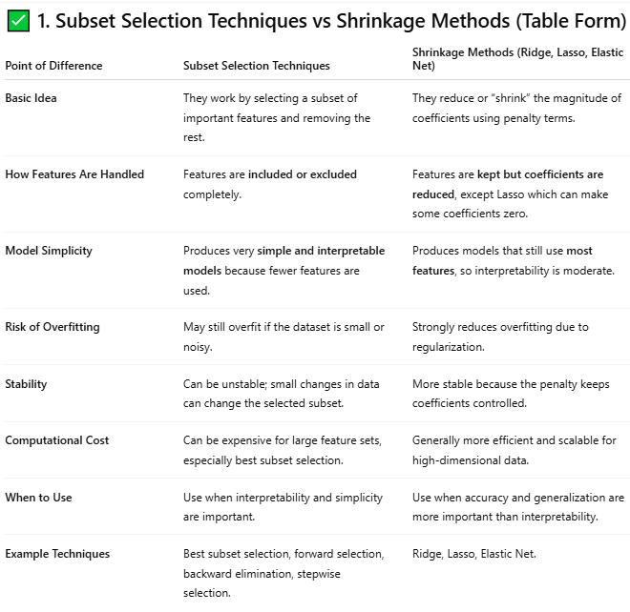

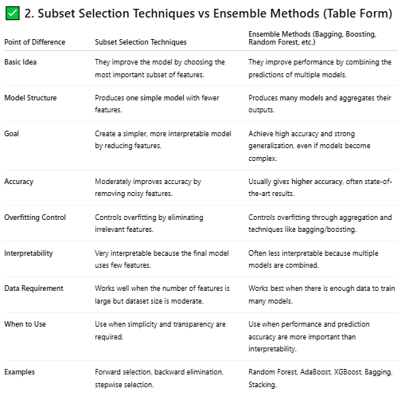

LDA Compute:
$$w=S_{w}^{-1}\left(U_{1}-U_{2}\right)$$
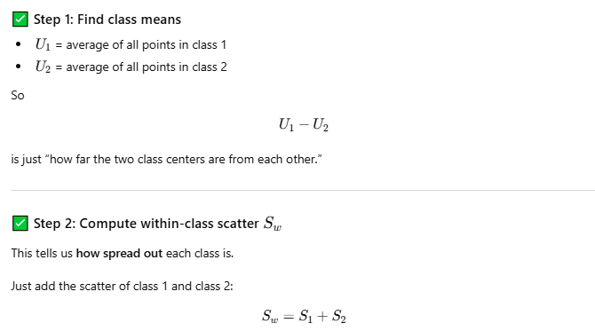
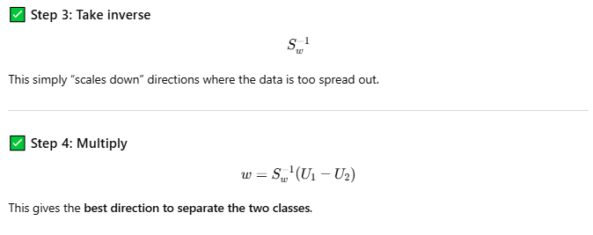

✅ Feature Reduction in LDA (Short Steps)
- Compute class means for each class.
- Calculate within-class scatter (S_w) to measure spread inside each class.
- Calculate between-class scatter (S_b) to measure separation between class means.
- Solve the eigenvalue problem for (S_w^{-1} S_b).
- Select top eigenvectors with the largest eigenvalues (they give maximum class separation).
- Project data onto these selected eigenvectors to get reduced features.

